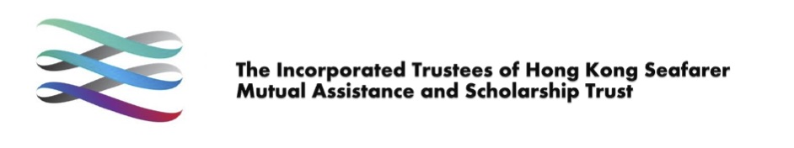
Hong Kong Maritime Scholarship Fund
Mechanical Engineering Seafaring Scholarship
Application Guidelines

Introduction
To foster excellence, encourage outstanding achievements, and build a vibrant, diverse, and competitive pool of professionals and technical personnel to support Hong Kong’s future maritime development, the Administrative Committee of the Hong Kong Seafarer Mutual Assistance and Scholarship Trust approved the Higher Diploma in Mechanical Engineering Seafaring Scholarship, effective 26 July 2024.
In accordance with the resolution of the Administrative Committee, the scholarship was later expanded to include holders of a bachelor’s degree in mechanical engineering or an equivalent programme, with effect from 20 January 2026. The scholarship was renamed the Mechanical Engineering Seafaring Scholarship. Each successful applicant may be awarded up to HK$60,000.

Eligibility
The applicant must –
- be a Hong Kong resident;
- Meet one of the following academic and training requirements:
(a) Completed the Higher Diploma in Mechanical Engineering at the Hong Kong Institute of Vocational Education (IVE), and served as an engine cadet onboard a foreign-going vessel after 26 July 2024 (Phase 1), or
(b) Graduated from a recognized bachelor’s degree in engineering or an equivalent programme at a Hong Kong university or institute, and served as an engine cadet onboard a foreign-going vessel after 20 January 2026 (Phase 1); or
(c) Completed the Preparatory Course for Certificate of Competency Class 3 Seagoing Marine Engineer Officers offered by the Maritime Services Training Institute, and served as an engine cadet onboard a foreign-going vessel after 20 January 2026 (Phase 1).

- Accepted a contract as a Marine Engineer Officer on a foreign-going vessel after obtaining a Certificate of Competency (Marine Engineer Officer) Class 3 recognized by the Marine Department (Phase 2).

Details
The scholarship will be awarded in two phases:
Phase 1: 30% of the scholarship upon completion of six months’ sea service on foreign-going vessels.
Phase 2: 70% of the scholarship upon acceptance of a contract as a Marine Engineer Officer on a foreign-going vessel.

Application Procedure
Phase 1 Application
Applicants must submit the following documents to the Secretariat of the Hong Kong Seafarer Mutual Assistance and Scholarship Trust:
- Completed Individual Seafarer/Student Hong Kong Maritime Scholarship Fund Application Form.
- Copy of Hong Kong Identity Card or Hong Kong passport (personal information page).
- Proof of academic qualification:
  - Certificate of Higher Diploma in Mechanical Engineering (IVE), or
  - Proof of graduation from a recognized bachelor’s degree in mechanical engineering or equivalent programme at a Hong Kong university/institute, or
  - Proof of completion of the Preparatory Course for the Certificate of Competency Class 3 Seagoing Marine Engineer Officers at the Maritime Services Training Institute.
- Copies of relevant pages from the Seafarer’s Employment Registration Book, including:
- Personal information,
- Registration record, and
- Sign-on/off pages showing:
  - Date of joining the first foreign-going vessel
  - Capacity as cadet, and
- At least six months of service before the date of leaving the vessel.
Phase 2 Application
Applicants must submit all documents required for Phase 1, plus:
- Copy of Marine Engineer Officer Certificate of Competency Class 3 recognized by the Marine Department, and
- Copy of employment contract as a Marine Engineer Officer on a foreign-going vessel, or other relevant employment documentation.
Applicants may also be required to provide a personal statement or attend an interview as part of the selection process.

Deadline for Application
Please submit the application within 3 years after completion of the required seagoing service / employment.

Remarks: Successful applicant is required to attend related functions /ceremonies upon request by the Hong Kong Seafarer Mutual Assistance and Scholarship Trust or the Hong Kong Institute of Vocational Education.
The Administrative Committee of the Hong Kong Seafarer Mutual Assistance and Scholarship Trust shall have the power in its discretion to approve the application and decide the amount approved thereof.
(Updated 6 February 2026)

